💻𝗜𝗺𝗽𝗹𝗲𝗺𝗲𝗻𝘁𝗶𝗻𝗴 𝗦𝗹𝗼𝘄𝗹𝘆 𝗖𝗵𝗮𝗻𝗴𝗶𝗻𝗴 𝗗𝗶𝗺𝗲𝗻𝘀𝗶𝗼𝗻 (𝗦𝗖𝗗) 𝗧𝘆𝗽𝗲 𝟮 𝗶𝗻 𝗗𝗮𝘁𝗮𝗯𝗿𝗶𝗰𝗸𝘀 𝘄𝗶𝘁𝗵 𝗣𝘆𝗦𝗽𝗮𝗿𝗸
🔍 Key Logic:
🆕 Inserting New Records – Identify and load the records that are new into the target table.
⏳ Marking Existing Records as Expired – Update the current records with an end date to signify they are no longer active.
🔄 Inserting Updated Records – Add updated records as new rows while maintaining the historical data of the previous state.
I've also included a snapshot illustrating the process of marking existing records as expired.
For the full implementation, check the code here:
https://lnkd.in/eJFHXAYf
Follow Abhishek Agrawal for more such content.
🔗 Join our WhatsApp channel to stay updated on Azure Data Engineering!
https://lnkd.in/dUuscrch 📲
hashtag#dataengineering hashtag#cloud hashtag#scd hashtag#azure hashtag#databricks hashtag#spark
Activate to view larger image,
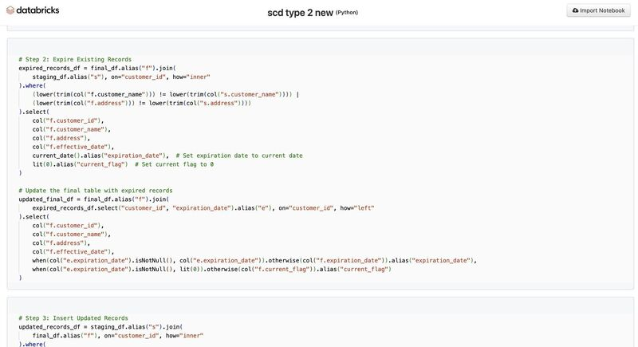

Ever wondered why the same customer appears multiple times in a dimension table?
You're debugging a report.
A customer named John has moved from New York to San Francisco.
Now comes the big question:
👉 Should you update the existing record?
👉 Insert a new record?
👉 Keep both the old and new values?
The answer depends on the Slowly Changing Dimension (SCD) strategy you choose.
Here's the simplest way to remember it:
🟦 SCD Type 1 – Overwrite
↳ Updates the existing record.
↳ No historical data is retained.
↳ Best for correcting mistakes like spelling errors or invalid values.
🟩 SCD Type 2 – Preserve History
↳ Creates a new record for every change.
↳ Maintains complete historical data using effective dates or current flags.
↳ Perfect for customer addresses, employee departments, pricing history, and regulatory reporting.
🟪 SCD Type 3 – Store Previous Value
↳ Adds extra columns to keep the previous value.
↳ Retains limited history (usually one previous version).
↳ Useful when comparing the current value with the immediately preceding one.
A simple way to think about it:
📝 Type 1: "I only care about today."
📚 Type 2: "I need the complete story."
🔄 Type 3: "I just want to know what changed last time."
One mistake I often see is teams implementing Type 2 everywhere because it seems like the safest option.
But full history comes at a cost:
↳ More storage
↳ More complex joins
↳ Slower reporting
↳ Higher maintenance
A good Data Architect doesn't preserve history by default.
They preserve only the history that delivers business value.
Question for Data Engineers and Architects:
If a customer's email address changes, which SCD type would you implement—and why?
📌𝗥𝗲𝗴𝗶𝘀𝘁𝗿𝗮𝘁𝗶𝗼𝗻𝘀 𝗮𝗿𝗲 𝗰𝗹𝗼𝘀𝗶𝗻𝗴 𝘀𝗼𝗼𝗻!
𝗗𝗼𝗻'𝘁 𝗺𝗶𝘀𝘀 𝘆𝗼𝘂𝗿 𝗰𝗵𝗮𝗻𝗰𝗲 𝘁𝗼 𝗷𝗼𝗶𝗻 𝗼𝘂𝗿 𝟰𝘁𝗵 𝗗𝗮𝘁𝗮 𝗘𝗻𝗴𝗶𝗻𝗲𝗲𝗿𝗶𝗻𝗴 𝗖𝗼𝗵𝗼𝗿𝘁 𝗮𝗻𝗱 𝗯𝘂𝗶𝗹𝗱 𝘁𝗵𝗲 𝘀𝗸𝗶𝗹𝗹𝘀 𝗻𝗲𝗲𝗱𝗲𝗱 𝘁𝗼 𝗹𝗮𝘂𝗻𝗰𝗵 𝘆𝗼𝘂𝗿 𝗗𝗮𝘁𝗮 𝗘𝗻𝗴𝗶𝗻𝗲𝗲𝗿𝗶𝗻𝗴 𝗰𝗮𝗿𝗲𝗲𝗿. - https://lnkd.in/gPiDZuyS
Activate to view larger image,
